

School of

Electronics and Communication Engineering

**ADLD**

Course Project On

**“Digital Clock on FPGA”**

Team No: 15

1. Kanishk Yallurkar USN: 01FE19BEC075 Roll No – 232
2. Sushmita Hubballi USN: 01FE19BEC219 Roll No – 444

Semester: VI (2022)

**Problem Statement:**

Digital Clock on FPGA

**Flow Chart:**

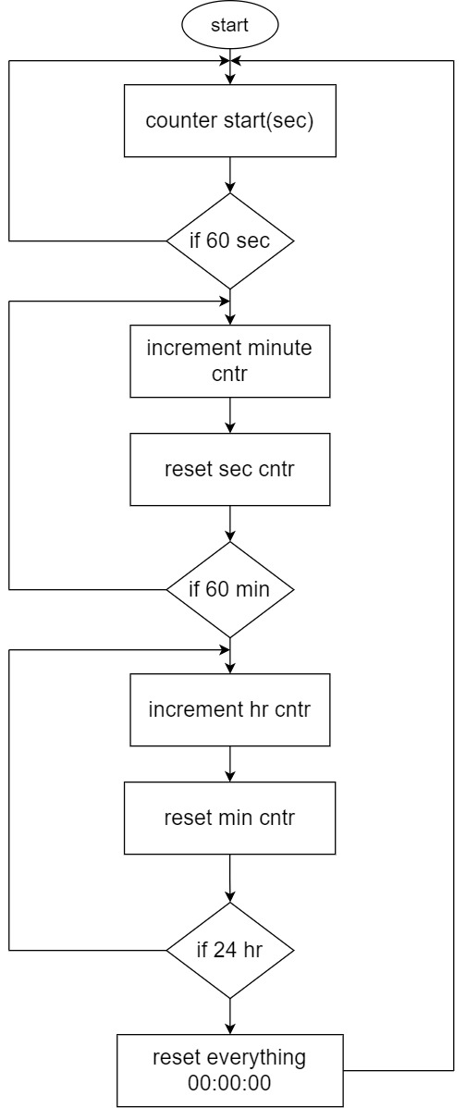

**FSM:**

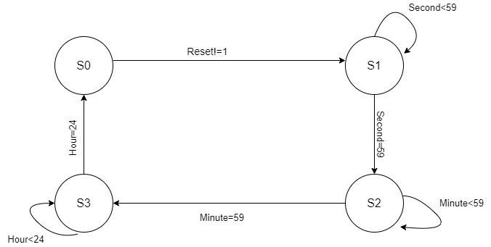

**Simulation Results:**

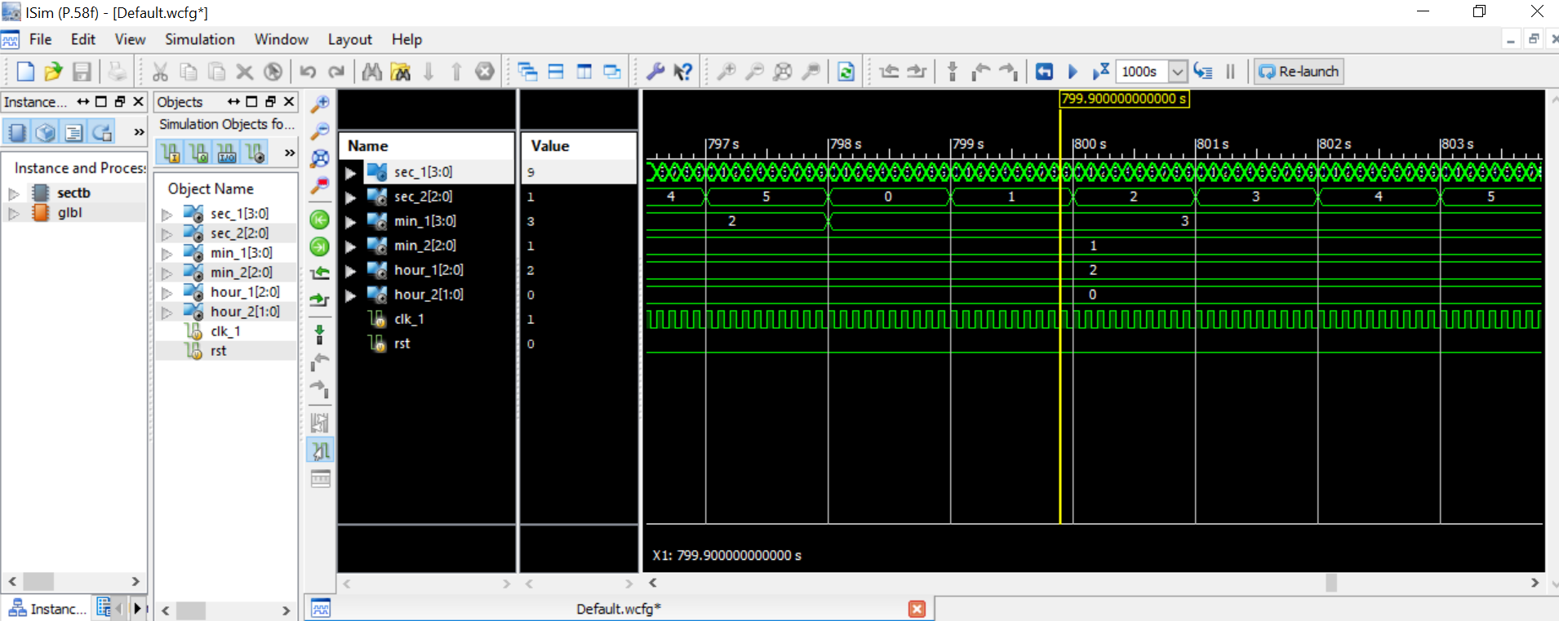

**Synthesis:**

RTL schematic:

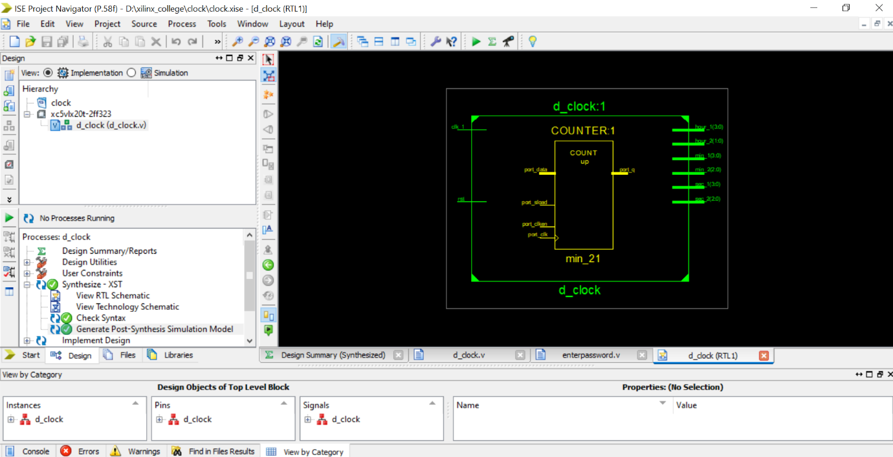

Technological schematic:

